**General Purpose Utilities in Linux**

**1)Display the calender for the month of March 2012**

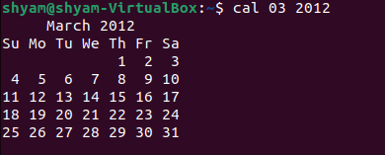

**2)List all the files and directories of the directory /usr/lib on the terminal. Now put the same information in a file named results. Display the contents of the file results now.**

